Pilgrim Primary Academy
Oxford Street, Plymouth, PL1 5BQ
Tel: 01752 225319
E-mail: contactus@ppsonline.org
Headteacher: Mrs L Meek (BA Hons, PGCE, N.P.Q.H)

15th December 2023
Dear Parents / Carers

We are pleased to be able to run some more exciting after school clubs again this term. These clubs will run from week commencing 8th January 2024 until week ending 22nd March 2024. There will be a £12.00 charge per club; however, for pupil premium children there will be a reduced charge of £8.50. To confirm, this is a one-off fee (not weekly).

You can now apply for your children to take part in the activity clubs listed below. Each club will run from 3.15 to 4.15pm. You should indicate by putting a number in order of preference to which you would like your child to attend. (Please only pick a maximum of two choices)

You are not required to pay on Parentpay until you receive confirmation as to whether your child has been allocated a space. It is likely that clubs will be over-subscribed. If this is the case the following will be taken in to consideration: -

- Very good attendance at any clubs now or in the past
- Behaviour and attitude in School
- Chance for a child to attend a club who has not done so before

If there are still more children than spaces available, children will be randomly selected (names out of a hat style).

In order to collate all this information, we ask that you complete the reverse side of this letter and return the sheet to the SCHOOL OFFICE by Tuesday 2nd January 2024.

We will inform you whether your child has gained a place at a club on Friday the 5th January 2024 and clubs will start from Monday 8th January 2024.

Yours sincerely
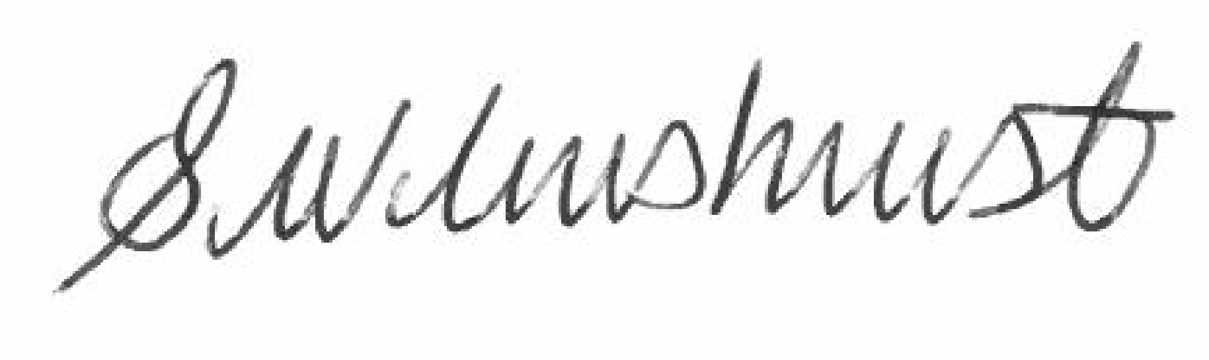
Ms S Wilmshurst
Assistant Headteacher

All clubs listed below will finish at 4.15pm

Day | What | Year groups able to attend | Club led by… | Number in order of preference
Monday | Basketball | Y4,Y5 & Y6 | Plymouth Patriots
 | Forest School (To start 19th February 2024) | Y5 & Y6 | Mr Christensen
Tuesday | Football | Y5&Y6 | Mr Newell
 | Board games club | Y3,Y4,Y5,Y6 | Mr Oliver
 | Art club | Y2 | Miss Putt
Wednesday | Football | Y3&Y4 | Plymouth Argyle
 | Art Club | Y5 & Y6 | Mr Monterio
 | Tag rugby | Y3,Y4,Y5,Y6 | Mr Newell
Thursday | Girls Football | Y3,Y4,Y5,Y6 | Miss Plaice
 | Creative Writing Club | Y4,Y5 & Y6 | Miss Fraser
 | Athletics | Y3 & Y4 | Mr Newell
 | Get crafty art club | Y1 | Miss Webb
Friday

After School permission slip
I wish my child to attend an after-school club
Childs Name .................................................................................... Year Group………….

My child will be picked up after their club
My child has permission to walk home

If your child has selected two clubs and are lucky enough to be allocated both of their choices, please advise if you wish them to attend both or not. YES NO

Parent / carer signature ..................................................... Date: ………………………

