25th January 2019
Dear Parents/carers,

Further to our Art project, I am pleased to inform you that Drake Circus would like us to participate in a ‘hanging of the canvasses’. They have mounted and protected them behind glass and would like to take photographs of the children, who participated, to publish on their website. The newspapers will also be writing an article to celebrate their hard work. The event will be on Wednesday 30th January at 11am and, as this is during the morning, it will not affect their lunch. Drake Circus require their own permission form for the photographs, so if you consent please return the form ASAP.

This is a wonderful opportunity for your child and they will get to see where the canvasses will be displayed.

Yours sincerely
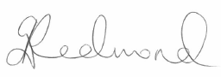
Ms. Redmond

