25th January 2019
Dear parents/carers,

It is our class trip this coming Tuesday 29th January to Kents Cavern in Torquay.
We will be leaving school at 9:15am on a coach and will be returning to school at 3pm. Please collect your child at the normal time.

For the trip, please can your child come in comfortable clothes, sensible shoes and a coat in case it rains. Can your child also bring a backpack in which they can carry their packed lunch in.

If you have any questions, please do not hesitate to speak to your child’s class teacher.

Yours sincerely
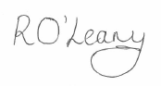
Mrs. O’Leary and Miss. Dale

