29th May 2020
Dear Parents and Carers,
Phased wider opening of schools in England for Foundation, Year 1 and Year 6
Following my communication to you earlier in the week, the Government has now confirmed that schools will begin to offer places for children in Foundation, Year 1 and Year 6 from June 1st. The guidance document that was sent this week to all families outlines the current plan for this (this can be found in the News section on our website home page entitled ‘Re-opening Letter’).
Thank you for those families from Foundation and Year 1 classes who have completed their return form to either accept or decline their place. For those families in Foundation or Year 1 who have not yet done this, we require you to do this as soon as possible – without this information we cannot make plans and allocate children to a class base/teacher. For those parents who do not complete the Survey by Saturday 30th May, we will assume no place will be required. The link can be found here:
https://forms.gle/MY72xmCJXxhtvCY76
Staff will be in school on Monday and Tuesday of next week to carry out additional training and to get prepared for children returning. We will start our phased return with our youngest children and look forward to welcoming them back:
Foundation on Wednesday June 3rd
Year 1 on Monday June 8th
Year 6 on Wednesday June 10th (Year 6 families – we will send you a link for booking a place next week)

We will be sending more detailed information to families in Foundation and Year 1 on Monday, informing you of the exact session times, which entrance/exit to use and the ‘Bubble’ and staff member that your child has been allocated. We will then do the same for Year 6 at a later date.
Whilst this change will be a challenge for all of us, staff here at Pilgrim are very much looking forward to seeing the children again – we will work very hard to ensure that the children enjoy their time at school and that they are happy and safe.
Home Learning
Whilst there has been a lot of focus in the media on certain year groups returning to school, I want to reassure you that the children who are remaining at home in other year groups continue to be an equal priority. Home learning will continue for all children who are not able to be in school and we are committed to maintaining the same standard for all children. Activities will resume on Monday, as our new half term begins, so please check in on Google Classroom or continue with your paper packs. I would like to thank all you all for doing so much learning with your children over the last few months – I know that it will have been hard work but your support in this is very appreciated.
Star Learners
Staff continue to be impressed with the attitudes of the children completing their home learning and would particularly like to recognise the following children:

Bear Cubs – Zackery S | Fox Cubs – Helen L
Seastars – Jai-Reece J | Seahorses – Robyn F
Owls – Lacey R | Penguins – Alison O
Chameleons – Piotr B | Geckos – Casper B
Lions – James W | Tigers – Roxy H
Orcas – Theo M | Dolphins – Ayesha B
Falcons – David O | Eagles – Cayden M

Staff Update
We wish Miss Hardington good luck as she starts her maternity leave and welcome back Miss Camm from her maternity leave. Miss Camm will be taking over from Miss Hardington as teacher in Year 4 Lions class.

Farewell to a very valued member of our school community…
This week, we have said a very sad farewell to Mrs Barbara Stephenson
as she moves into her retirement. Mrs Stephenson has given over
25 years of service to Pilgrim Primary and has seen thousands of
children grow and learn over that time (some of our parents too, no doubt!).
There are not many people who can say that they have dedicated 25 years
of their life to one school and throughout this time, Mrs Stephenson has
always given 100% commitment to the children and families of our
community. On behalf of all staff, children parents and Governors, I would
like to express my heartfelt thanks to Mrs Stephenson – she will leave
a lasting legacy at Pilgrim and will be very much missed.

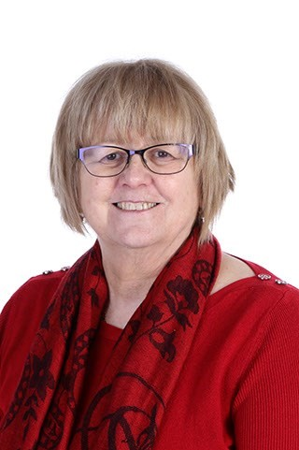

As we move into this final half term of this academic year and into a phased period of school reopening, I would like to thank all of the staff, children pupil and parents/carers; the last few months has been tough on everyone but I think we have got through it pretty well so far! I very much hope we can continue to work together in this next phase in the same spirit of co-operation and understanding.

Have a very good weekend everyone and I look forward to seeing a few more little faces back in school from Wednesday next week!

Yours faithfully
Mrs Meek
Headteacher

