Support for parents and families
Local contact numbers
- Mind Devon - Mental Health Charity 01752 512280
- The Zone Plymouth - information, advice, counselling and support services to young people. 01752 435122
- CAHMS- Urgent Mental Health support team 01752 435122
- PDAS- Plymouth Domestic Abuse Service 0800 458 2558
- Crisis Support Plymouth 01752 668000
- Simply Counselling (adults) 01752 560900
- Citizen Advice Bureau Plymouth 0300 3309 043
- Gateway – to report concerns about a young child/person 01752 668000 option 1
- Plymouth food bank 01752 668000 option 4

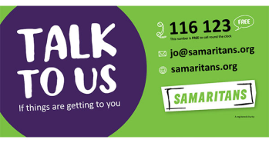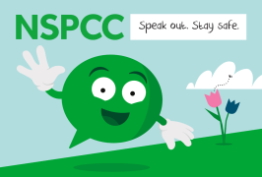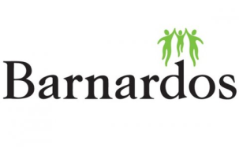
National Support numbers

- Domestic Violence victim support 08081689111
- Mind 0300 123 3393
- Samaritans 116 123 (free from any phone)
- NSPCC 0800 800 5000 (Adults)
- NSPCC 0800 1111 (children under 18)
- Saneline 0300 304 700
- Childline 0800 1111
- Supportline 01708 765200
- Women’s aid 24 hr helpline 0808 2000 247

National support contacts

www.mentalhealth.org.uk
www.mind.org.uk
www.rethink.org
www.sane.org.uk/support
www.youngminds.org.uk
www.barnardos.org.uk
www.childline.org.uk
www.citizensadvice.org.uk

