01/10/2019
Dear Parents/Carers,

I just wanted to drop you a line to keep you up to date with how the term is progressing so far. The children returned to school after the summer break really positively and got stuck straight in! We have had 56 new children into our Foundation stage. They are now in with us full time and they seem to be settling in very nicely. It is also great to welcome so many new families into our school community.

Summer building works

The MUGA - The children were very excited to come back from the summer holidays to find our Multi Use Games Arena (MUGA) constructed on the Key Stage 2 playground. The MUGA will allow us to zone the ball games into one area at playtimes and will be invaluable for PE lesson (saving children the time and frustration of forever chasing lost balls around the playground!). The MUGA has been funded from the Sports Premium Grant, which schools receive from the Government, and also from our own School Fund (money raised from Summer Fairs, discos, etc.).
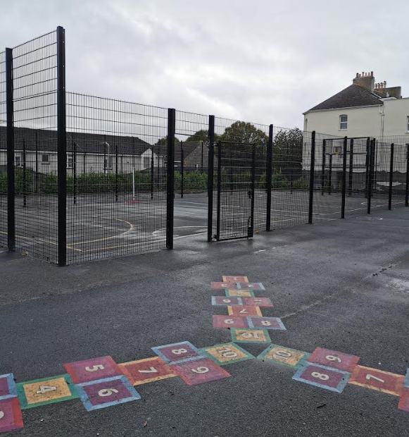

Additional fencing and CCTV– In the summer holiday, we have had some sections of fencing added to the height of the fence along the boundary to Oxford Street near to the school entrance to make this section of fencing more secure. We are also looking to install a few CCTV cameras around the front entrance of school and I very much hope to get these installed before Christmas.

Parent Pay

We are now a school that uses the Parent Pay portal. Parent Pay is designed to make it easier for parents/carers to pay for meals, clubs, trips, etc. You have all been sent login details. However, if you need help with accessing Parent Pay please do not hesitate to contact our ladies in the office. We have noticed that some families have not accessed Parent pay yet so please do log on and start using it – otherwise you may find that you have debts mounting up.
Dates and Calendar

The dates for the coming Autumn term are attached to this letter as well as the calendar for the whole academic year. Please note that there is a Non-Pupil day on Friday 18th October (just before Half Term) and that it is our Harvest Festival assembly on Friday 11th October – more details will follow.

CaterEd Survey

CATERed is the schools led local authority trading cooperative jointly owned by your child's school and the Council.

Our aim and objective is to buy fresh, seasonal, locally sourced produce and ingredients and to cook them from scratch each day in your child's school to produce great tasting, freshly prepared hot food which meets and exceeds the Governments Standards for School Food so that every child, regardless of the school they attend, gets the right food and nutrients to grow and learn.

To ensure we're doing the very best, we need your help & for you to tell us what you think! Please click on the link below.

https://www.surveymonkey.co.uk/r/KDNPHQH

The Mustard Tree Charity Coffee Morning

Finally, thank you so much for all your contributions made towards this worthwhile charity last Friday. The total raised from MUFTI donations and the Coffee morning event was a whopping £337.00. Thanks to everyone who donated cakes – there were some really tasty treats on offer! The parent and children’s choirs sang beautifully and our visitor from the Mustard Tree was so impressed with the efforts that you all went to in order to support the charity. Thanks to Mrs Harris, our Parent Support Adviser and our PTFA members for their great organisation of this event.

Best wishes
Mrs L Meek
Head teacher

