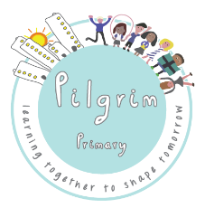
A Guide for parents/carers
– potential school wider opening –
June 1st
School routines & procedures during a phased school-reopening

This guide follows criteria set out by government and Reach South Academy Trust for implementing protective measures in schools for 1st June.

Key facts about phased school re-opening.
• Pilgrim has been open for Key worker children and children deemed vulnerable throughout the lockdown period and the Covid19 outbreak.
• Pilgrim will continue to remain open for Key worker children and vulnerable children during term time.
• The potential June phased re-opening for Foundation, Year 1 and Year 6 children remains conditional and based upon the ‘5 Test’ policy for re-opening that government have communicated, and also confirmation of staffing availability.
• Our current understanding is that a final decision on school re-opening nationally will be announced on 28th May.

To enable safe return of pupils to school and to minimise the potential for virus spread: adaptations to schools have been directed to focus on the following key points:
1. Social distancing is facilitated by school layout, routines and expectations.
2. Regular hand-washing, cleaning and hygiene routines are administered frequently throughout each school day.
3. Reducing class sizes and minimising interaction between pupil groups.
4. Clear procedures in response to a possible infection in school.

How will these 4 key points change school life during this phased period through to the end of this academic year?
The way children will learn, who they learn with, and what they learn will all need to be adapted.
This guide explains how the whole school community – pupils, teachers and parents - will need to adapt to new routines on a typical day. It is not going to be easy for many of us and it is not what we would choose school to be like but these are actions we must take (in line with all government guidance) to ensure the whole school community is kept as safe as possible and risk is minimised.

The timings of the school day
Start of Day
The start and end of the school day times will be staggered for different year groups to reduce the number of children and adults entering the school at one time:
 | Start | Finish
EYFS | 8.25 - 8.45 am | 2.10 - 2.30 pm
Year 6 | 8.20 - 8.30 am | 2.30 - 2.40 pm
Educare | 8.45 - 9.00 am* | 3.00 - 3.15 pm*
Year 1 | - - 9.15 am | 2.45 - 3.00 pm

*Wrap around care (breakfast and after school provision will also be available for Educare pupils (8.00 am – 5.45 pm – charges will apply)

Drop off and Pick up arrangements
What if I have children in 2 or more of these Year groups?
We will make a separate provision for parents with children in more than one of these year groups so that parents can drop off at the same time.

Who can come onto the school site?
We need to reduce the number of adults on the playground where possible. For younger children or for those children who may be anxious about coming into school, only one parent or carer may accompany them into the school grounds. Older children (Y6) can be left at the school gate for a member of staff to monitor them coming in. We will expect and trust our parent community to observe all social-distancing guidelines both on the paths and roads around school and when coming onto the school grounds. Members of the school leadership team will monitor the grounds to encourage social- distancing, ensuring it is observed by all members of the school community.

Where will my child enter the school building?
Along with specific drop off and pick up times, children will need to enter the site via one of the designated gates. All children, on entering the school site, will be asked to go to a clear collection point to wait by one of the designated socially distanced markers. Children will be collected by a member of staff from this area and taken into the school building. More information on which gate to use to enter the site, the location of your child’s drop off/pick up point and who your child’s key adult is will be sent once your child has a confirmed place.

Drop off/collection points will be marked:
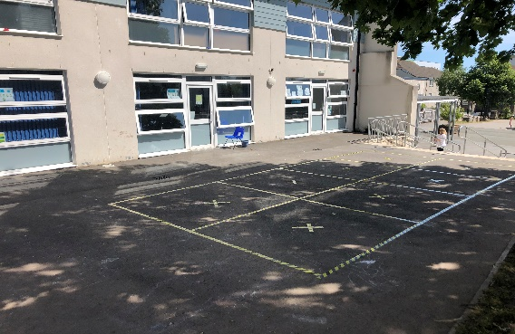

Children will enter through separate doors and move to their teaching bases with their adult. On entry to the school building the children will be asked to wash or sanitise their hands and then be registered in the usual way.

Clothing – what will my child wear?
Whilst we all love to see the children in school uniform, the school will operate a non-school uniform policy for this period. It is vitally important that all children and staff wear a clean and fresh set of clothes every day. As it is likely to be impractical for parents to provide a full clean uniform each day, home clothes will be worn. However, we will be sending guidance about acceptable clothing and particularly, safe footwear to choose during this time.

What the school will look like inside... How might learning change for my child?
“Bubble” Groups
Government guidelines state that class and group sizes must be limited to enable distancing in school. At Pilgrim, we will not be teaching children in full class sizes but in much smaller groups; we are calling these smaller teaching groups “Bubbles”.
A Bubble will usually be formed with up to 8 children from the same year group and provision for them will be carefully organised by the class teacher.
Educare pupils (children of key workers, vulnerable pupils) will also be organised into Bubbles.

Staffing of Bubbles
A Bubble will ordinarily be led by a teacher, but it is not possible for every child in every Bubble to be with their own class teacher. However, teachers will oversee all provision in their respective year groups with teachers from EYFS, Y1 and Y6 planning the learning for all those Bubbles. Teachers from other year groups in school will deliver content planned by the year group teachers. We will allocate children to teachers and into Bubbles once we know the final numbers of pupils attending and let you know this as soon as we possibly can.

Children will be taught in the same Bubble and by the same teacher/adult every day. Bubbles will use the same learning base every day. In this way we can reduce the amount of contact between adults, children and their environments. All children in all Bubbles will have their own designated resources, only to be used by them, and their own work spaces.

We will follow Government guidelines and mark safe distances within the learning spaces to ensure that social distances are maintained (as much as possible) at all times. The classrooms will be set as these photos demonstrate:

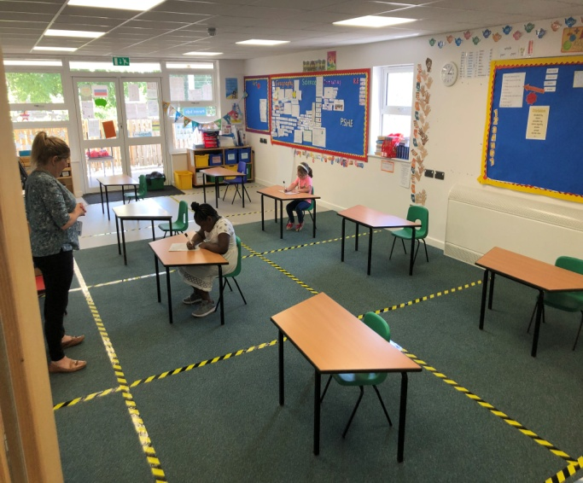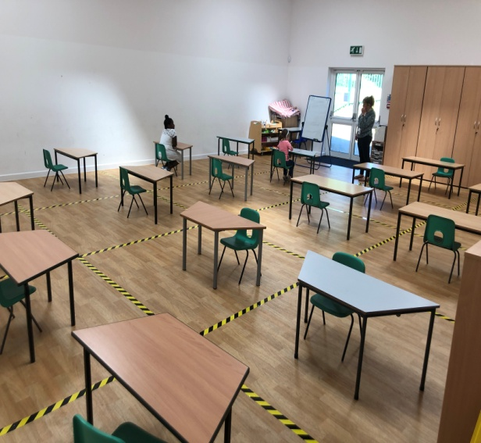

Whilst moving around school the children will be asked to follow the floor markings.
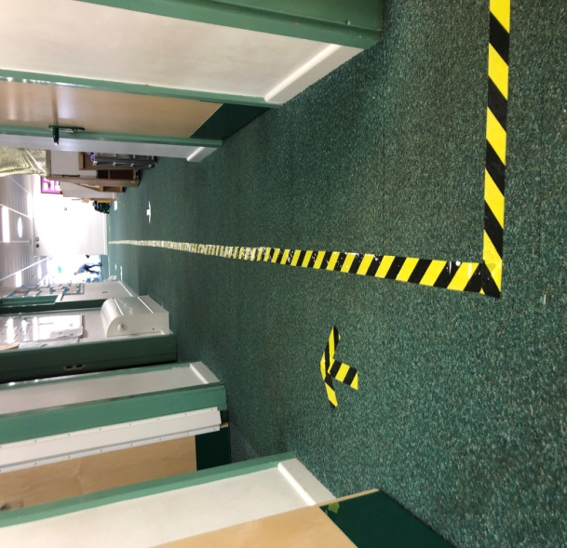

Bubbles cannot mix!
We must emphasise that the Government guidelines require that there is no interaction and mixing between these groups and therefore each Bubble should operate as a separate group throughout the school day – learning in their own group space, having break-times and lunchtimes as a Bubble themselves - not socialising and mixing with other groups of children. These groups, once formed, should remain the same for the entire half-term period.
We recognise that this will be challenging for the children and we will try to counteract the possible emotional impact of such grouping arrangements by considering friendship groups when constructing Bubbles. Bubbles may share the field, playground or forest school area for example so a Bubble will at least see other Bubbles around the school from a safe social distance! We are also planning other fun and positive initiatives to support pupil wellbeing.

Curriculum – what and how will my child learn?
The DFE have confirmed that schools are not expected to offer a broad and balanced curriculum during this re-opening phase. However, our provision will include access to tasks in line with those provided through the Google Classroom as well as additional Social, Emotional and Wellbeing activities and an emphasis on regular outdoor learning sessions. For the younger children there will be a focus on learning through play.

Behaviour
The school will continue to demand high levels of behaviour at all times both in the school building and on the playground. The current Behaviour Policy will continue to support this. Any children unable to follow the Behaviour Policy or any additional instructions to support social distancing, hygiene safe routines and following instructions may have to consider learning at home for the safety of all the other children and staff.

Lunch and refreshments
We are not able to provide any hot food at lunchtimes. Lunches will be packed-lunches only and will be eaten in class bases daily, or outside, weather permitting.
- Universal Free School Meals - CaterEd (our school meal provider) will be providing a packed-lunch for pupils in Foundation and Year 1 (and any Year 2 pupils in Educare) who are eligible for Universal Free School Meals.
- Pupils in receipt of Free School Meals - Pupils who are in receipt of Free School Meals will be expected to bring in a packed-lunch from home daily whilst the Edenred FSM eVoucher system remains in place.
- All Year 6 children will need to bring a packed lunch.

Lunchtime and break time
In order to limit the number of pupils on the playgrounds, playtimes will be staggered, with use of zoned play areas to ensure Bubbles remain separate - children will be closely observed to ensure distancing.

Hand washing routines
All children attending school will be supervised when washing their hands at least 7 times a day. The children will be asked to wash their hands:
- On entry to school
- Before break
- After break
- Before lunch
- After lunch break
- Before home time
- When children move between zones.
Pupils will also be asked by teachers to wash their hands if they observe a breech in hygiene.

First Aid

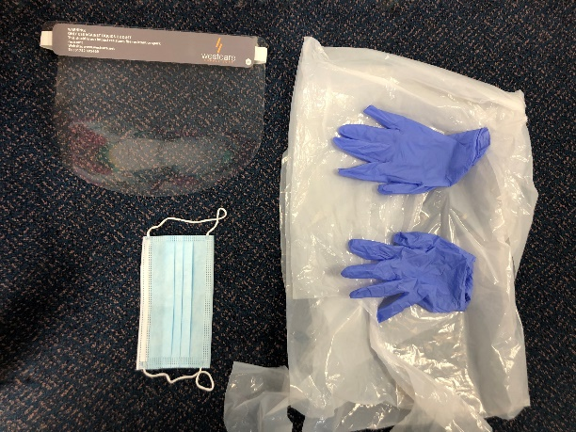
There will be a first aider available during each playtime and lunch time. They will wear full PPE (Personal Protective Equipment) to administer first aid should your child have an accident during these times. PPE includes gloves, mask, apron and visor (as shown).
Further first aiders will be on site throughout the school day to deal with any incidents or with pupils feeling unwell. There will be designated isolation bases for children feeling unwell to wait for their parents to pick them up.

Breakfast Club and After School Care
Wrap-around school care provision in Foundation, Year 1 and Year 6
We will not be able to offer any Breakfast Club or Pirates Club for pupils attending normal school provision in these year groups. Due to the strict guidelines relating to the grouping of children into distinct Bubbles, we cannot run any provisions where pupils mix before and/or after school with children from other year groups or other Bubbles.

Wrap-around school care provision in Educare
A good number of schools are not providing wrap-around care at all during this phase due to the complexities of provision but we would like to keep this as an option for our Key Worker families during this difficult time. Extended opening hours (8.00 am – 5.45 pm) will continue to be available as part of Educare only, offered to Key Worker families – charges for this extended provision will apply.
Children in Educare who need to attend Breakfast Club and/or After School Care (including those from EYFS/Y1 and Y6 who need wrap-around care) will be allocated to a specific Bubble in Educare and remain in that same Bubble and in the same location for the duration of the day. This is the only way in which this provision can be offered whilst maintaining the Bubble system securely.

The Educare booking system that is already in place will be maintained and we kindly request all bookings are still made at least for the forthcoming week ahead. All children attending Educare should be dropped at, and collected from, the front main entrance, observing all the social distancing rules in place in that area of school.

Hygiene and Cleanliness
PPE
Staff will not ordinarily wear Personal Protective Equipment when teaching children; this is in line with DFE recommendations.
Staff will be required to wear PPE (disposable aprons, gloves, face masks and sometimes visor) for the following situations:
1. Administering close-contact First Aid
2. Providing intimate care (assisting toileting for younger children)
3. If we need to isolate a child or staff member showing symptoms of Covid-19.

Additional cleaning
We will increase the volume of cleaning to enable an additional clean of central areas and communal spaces at the midday point, covering the cleaning of the toilets and hand-basins and communal touch point areas in corridors and classrooms. All class bases will be cleaned at lunch time in additional to after school cleaning.
Non-essential school equipment and soft furnishings will be removed in line with Government guidelines for health & safety and for ease of cleaning. All staff will also be vigilant about sanitising surfaces after teaching activities.

Signage & equipment
We are placing signage in and outside of the school to encourage children, staff and parents to maintain social-distancing and to remind everyone who uses our school site of the importance of personal hygiene, catching coughs in tissues, handwashing, etc.

Potential Covid-19 positive test in school community.
What if there is a case of Coronavirus in school?
We will follow all published guidance and continue to update our practices in this area regularly in line with any newly published scientific data and guidelines:
The person with symptoms must self-isolate for 7 days.
The people they live with or have been in contact with within a ‘Bubble’ with must isolate for 14 days.
All staff will be made aware of school procedures if a staff member or child shows symptoms of Covid 19.
If any pupil or adult tested positive for Covid-19 we would inform, seek advice and follow all instruction from Public Health England

Positive and fun initiatives to support positive pupil wellbeing
This information is all rather daunting we know, so this guide concludes on a positive note! We are planning a number of initiatives during this exceptional period to help the children enjoy school despite the constraints and look forward to some special activities each week. These may include:
- A weekly singing assembly
- Weekly forest school sessions.
- Regular use of the school field.
- Daily outdoor learning experiences
- Outdoor drama/story time
- Daily fitness and wellbeing activities
- Fun Friday activities in line with current provision.
- Weekly virtual celebration assembly

Final Thoughts:
We know that the wider opening of school in this context and under these circumstances are far from ideal but I hope that you can see from this guidance that we are working hard to reduce the risks to pupils and staff as much as we possibly can and in line with all information and guidance available to us.

For those parents of children in Foundation, Year 1 and Year 6 – you have a choice to make about whether you would like your child to return to school after June 1st. You know your child best and you will, I am sure, consider their ability to cope with the measures that will be in place on return to school. As always, we are here to help. We will still treat every child in our school as an individual and support their emotional well-being and happiness in all that we do. I am sure that you will make a decision with the best interest of your son or daughter at the heart.

For those pupils who are not in a position to return to school after June 1st, we will continue to offer a high - quality provision through Google Classroom and home learning packs and we will commit to maintaining contact with those children and families who are not able to attend school at this time.

Our Pilgrim community remains strong during this extended time of crisis and I thank you all for your continued understanding and support for Pilgrim Primary.

Mrs Lisa Meek

