
Pilgrim Primary Academy
Oxford Street, Plymouth, PL1 5BQ
Tel: 01752 225319
E-mail: contactus@ppsonline.org
Headteacher: Mrs L Meek (BA Hons, PGCE, N.P.Q.H)

Friday 17th March 2023
Dear Parents and Carers,

Comic Relief
The children and staff have had fun today, dressing up to raise money for Comic Relief. The children looked very colourful in their ‘funny’ clothes and many children enjoyed a Red Nose biscuit at break time - thanks to our school cook, Sue and CaterEd, for baking over 270 iced biscuits today! So far, we think we have raised around £232
This afternoon we had a whole school Comic Relief talent show with a panel of judges, music and bright lights. The children have voted in their classes for the act to represent their team. Who knew we had such confident and talented children at Pilgrim? The children entertained us with singing, dancing, comedy, magic, musical performances and even puzzle solving. All the children who performed on stage have received a certificate and a small prize today but we will be revealing the top 3 acts in Monday’s assembly, giving 1st, 2nd and 3rd place prizes. We alway love a talent show at Pilgrim but this year’s was above and beyond our expectations!
Thanks to all our families who donated today to this great charity. Please look on Facebook for more photos of our day.

Booking Process - Parent and Carer Consultation Meetings - Wed 22nd/Thurs 23rd
Next week we have Spring Term reports to go home and Parent and Carer Consultation meetings. For almost all classes, this will be next Wed and Thursday (with a slight change for Mrs Gough’s Bear Cub class - Monday 20th and Tuesday 21st - a separate letter will be sent to parents/carers in Bear Cubs)

You will receive an email to invite you to book a time that suits you for your meeting with your child’s appointment. The deadline for requesting an appointment is midday on Tuesday 21st March. You will then receive a confirmation email with the exact time of your meeting. These will be sent out later in the day on Tuesday 21st. I hope you will take this opportunity to come in, have your child’s Spring Report and find out how they have been progressing in school.


Sustrans Big Walk and Wheel
A letter is attached regarding this national event designed to get children and families walking or wheeling to school. Please try to join in our event - last year we won a prize and the whole school was treated to a stunt bike show. It is worth the effort to do a few more steps on the way to school in the next couple of weeks!

CaterEd school meal price increase
We have been informed by our school meals provider, CaterEd, that due to the cost of living crisis and food price increases, the children's school dinners will have a price increase that comes into force from Monday 17th April 2023. The cost of a school dinner from this date onwards will be £2.60 per day. Please see the accompanying letter from CaterEd for more details.

Pilgrim Curriculum Focus - What have we been up to?

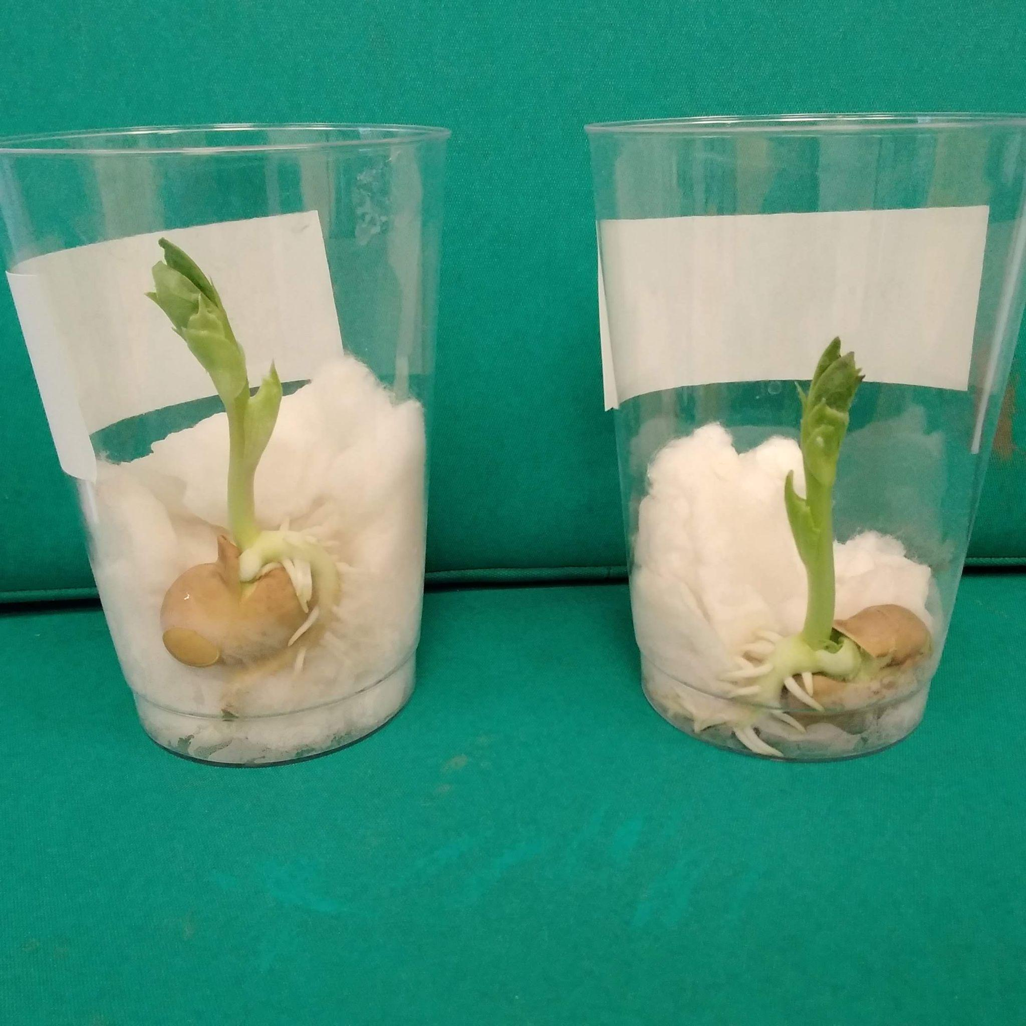
Reception Classes - growing beans
The children in Fox Cubs and Bear Cubs have been learning the Jack and
the Beanstalk story. They planted their own beans at the beginning of term to see how tall they would grow.
The children have been so excited watching what happens and seeing their beans grow. I am not sure that any of their beans were magic but it did add to the excitement!
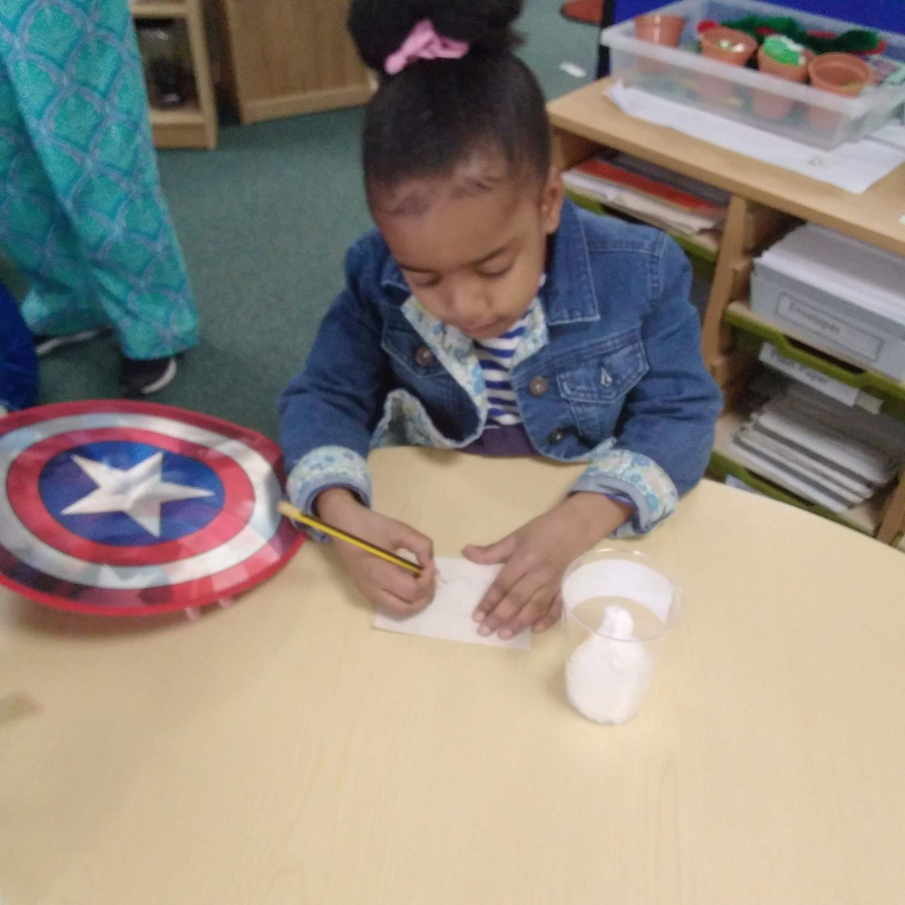
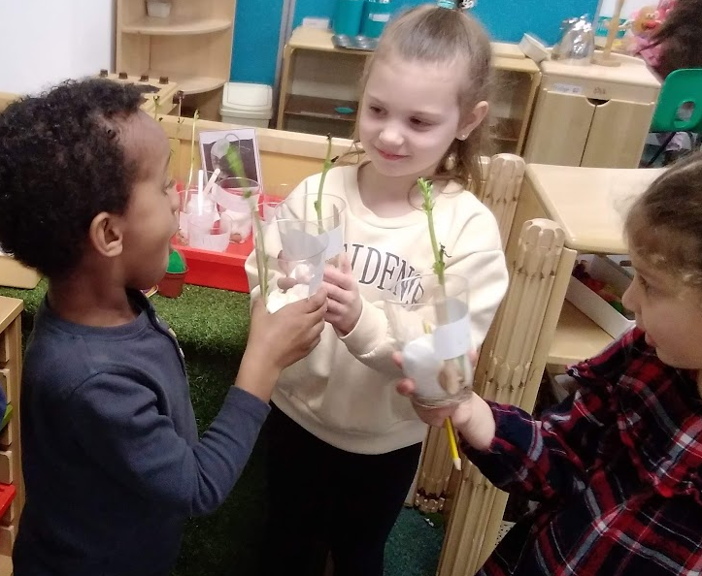


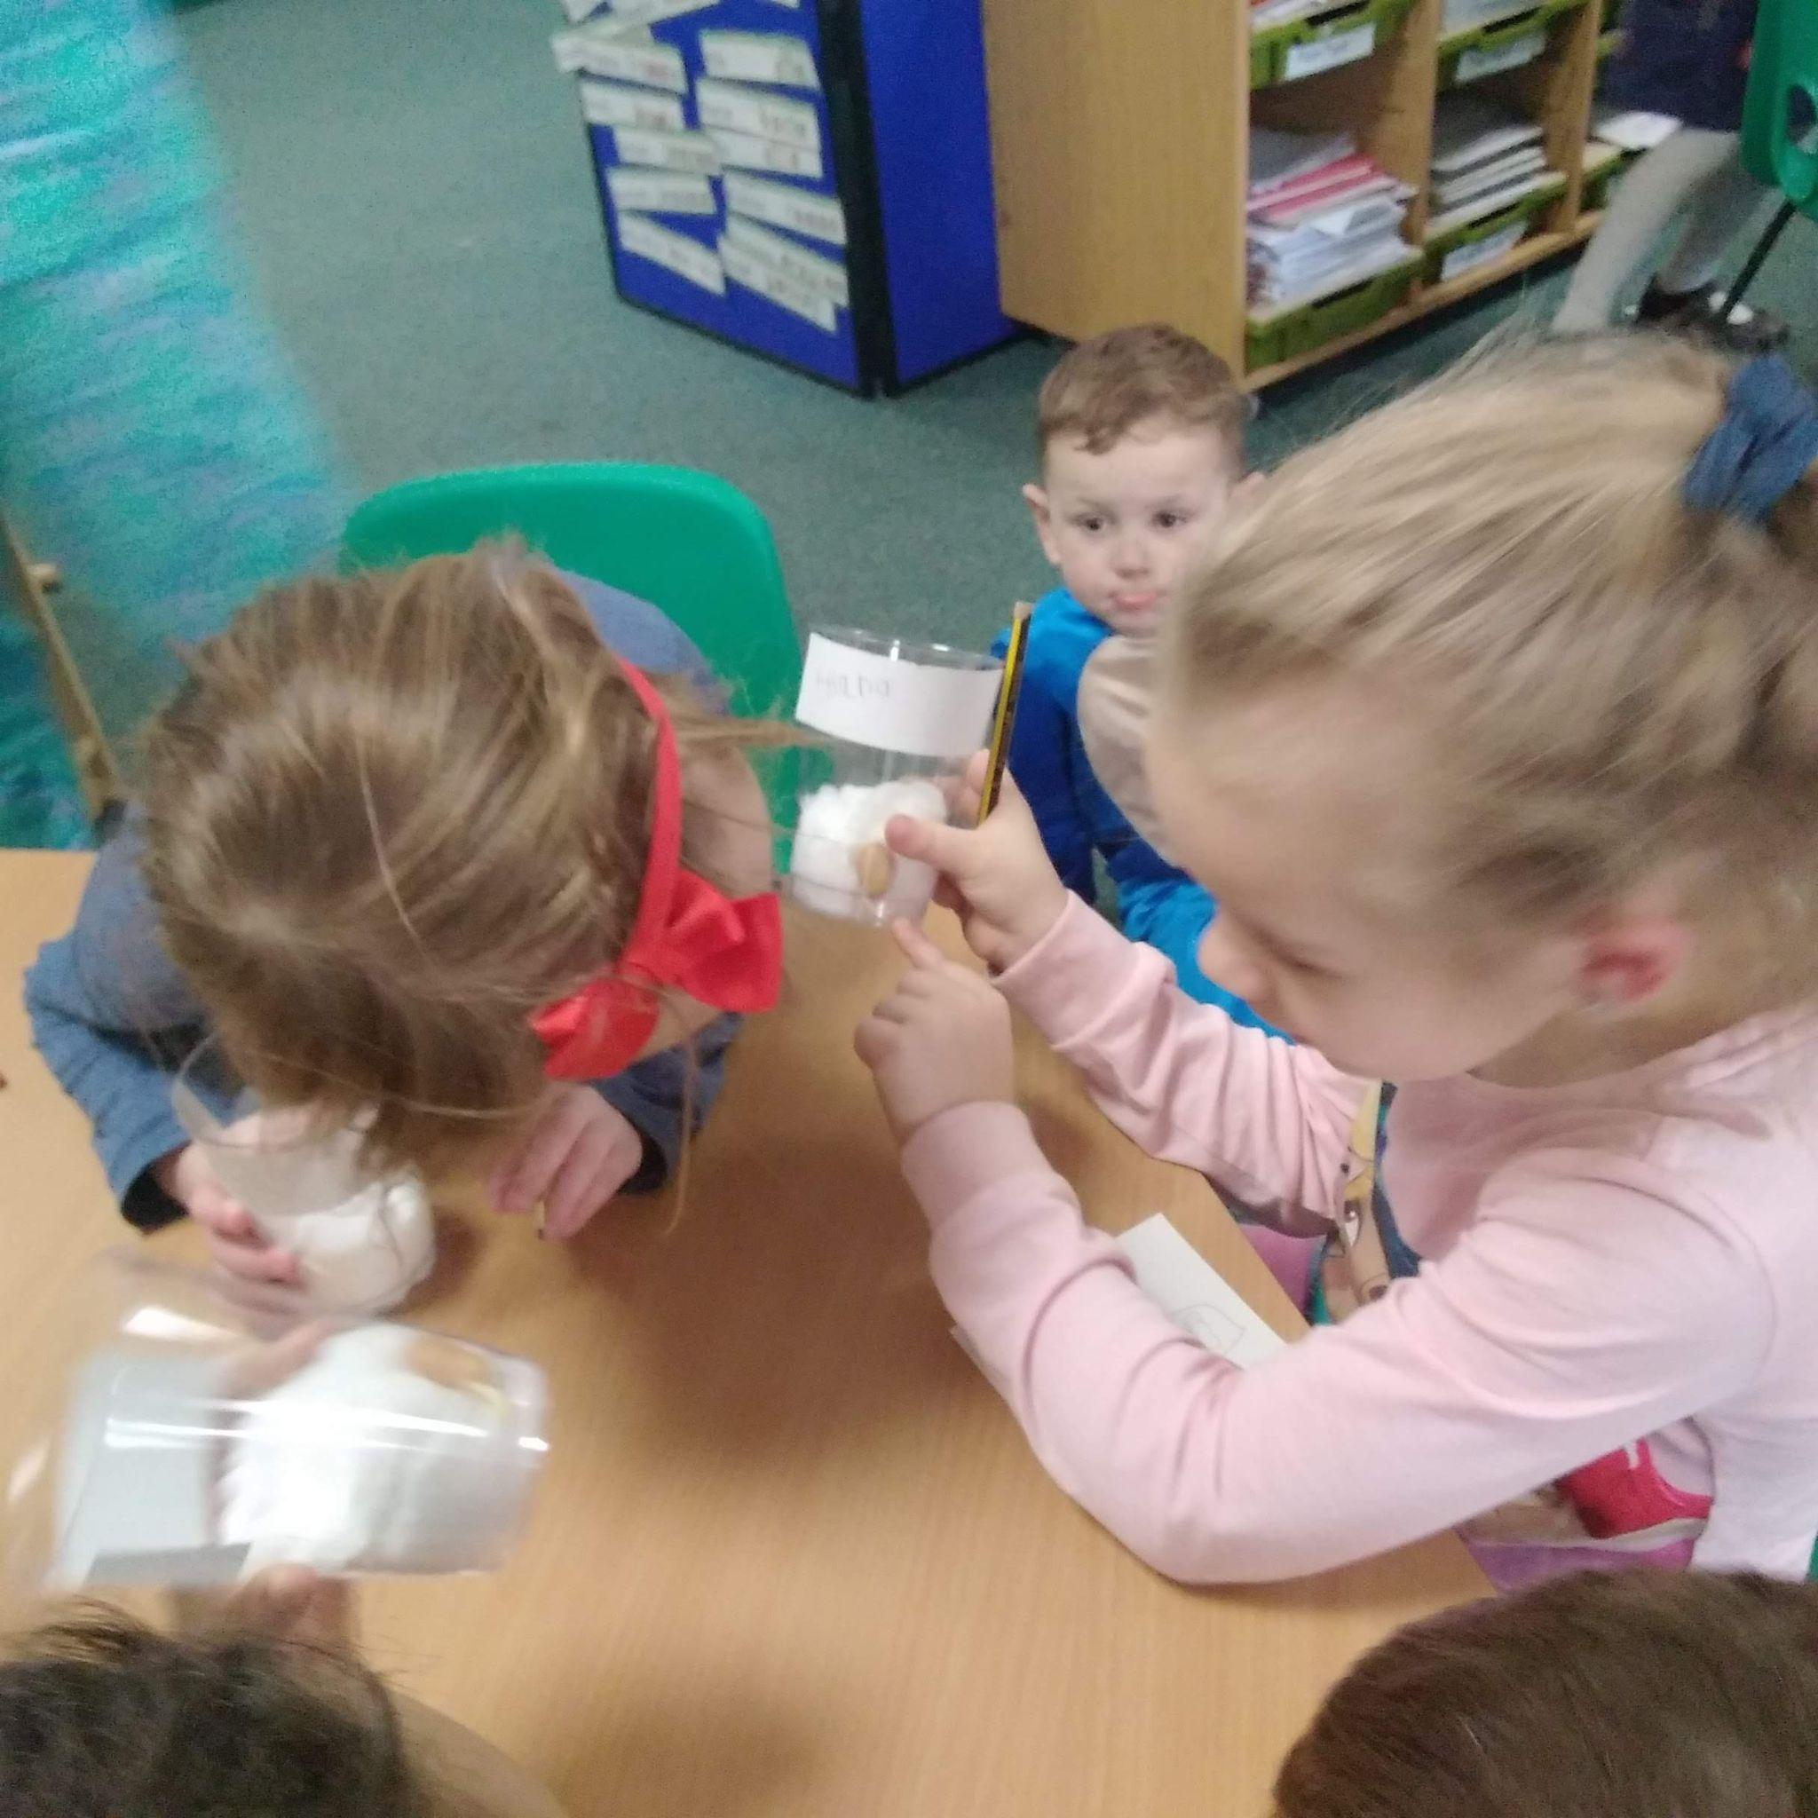
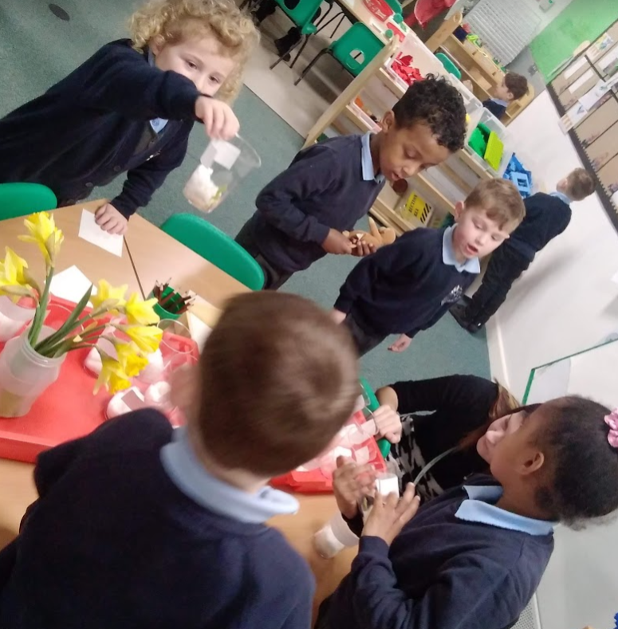

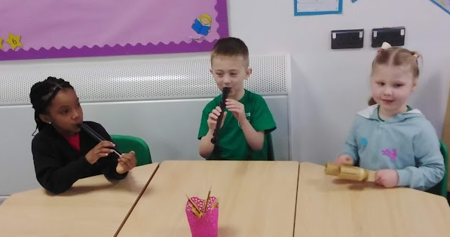
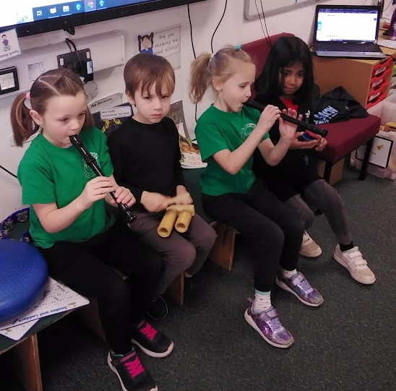
Year 1 - Music Making
We have enjoyed learning to tell stories using our body percussion and instruments. We have learned lots of new vocabulary, like timbre, dynamics and rhythm. We had to concentrate hard but we made some lovely sounds!

Year 2 Science Week activities - plants
Year 2 have been continuing their learning about plants by looking at vegetables. After learning about the parts and functions of a plant, we were identifying which vegetables grow on each part of the plant.
We sorted flower vegetables, stem vegetables, leaf vegetables, root vegetables and seed vegetables. We never realised where they grew. We also realised that we all love vegetables!
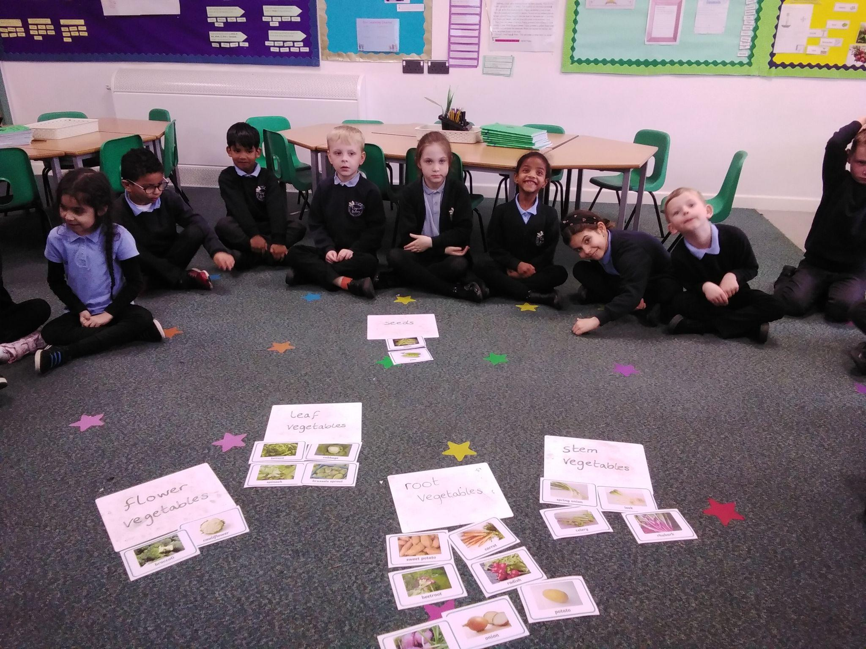
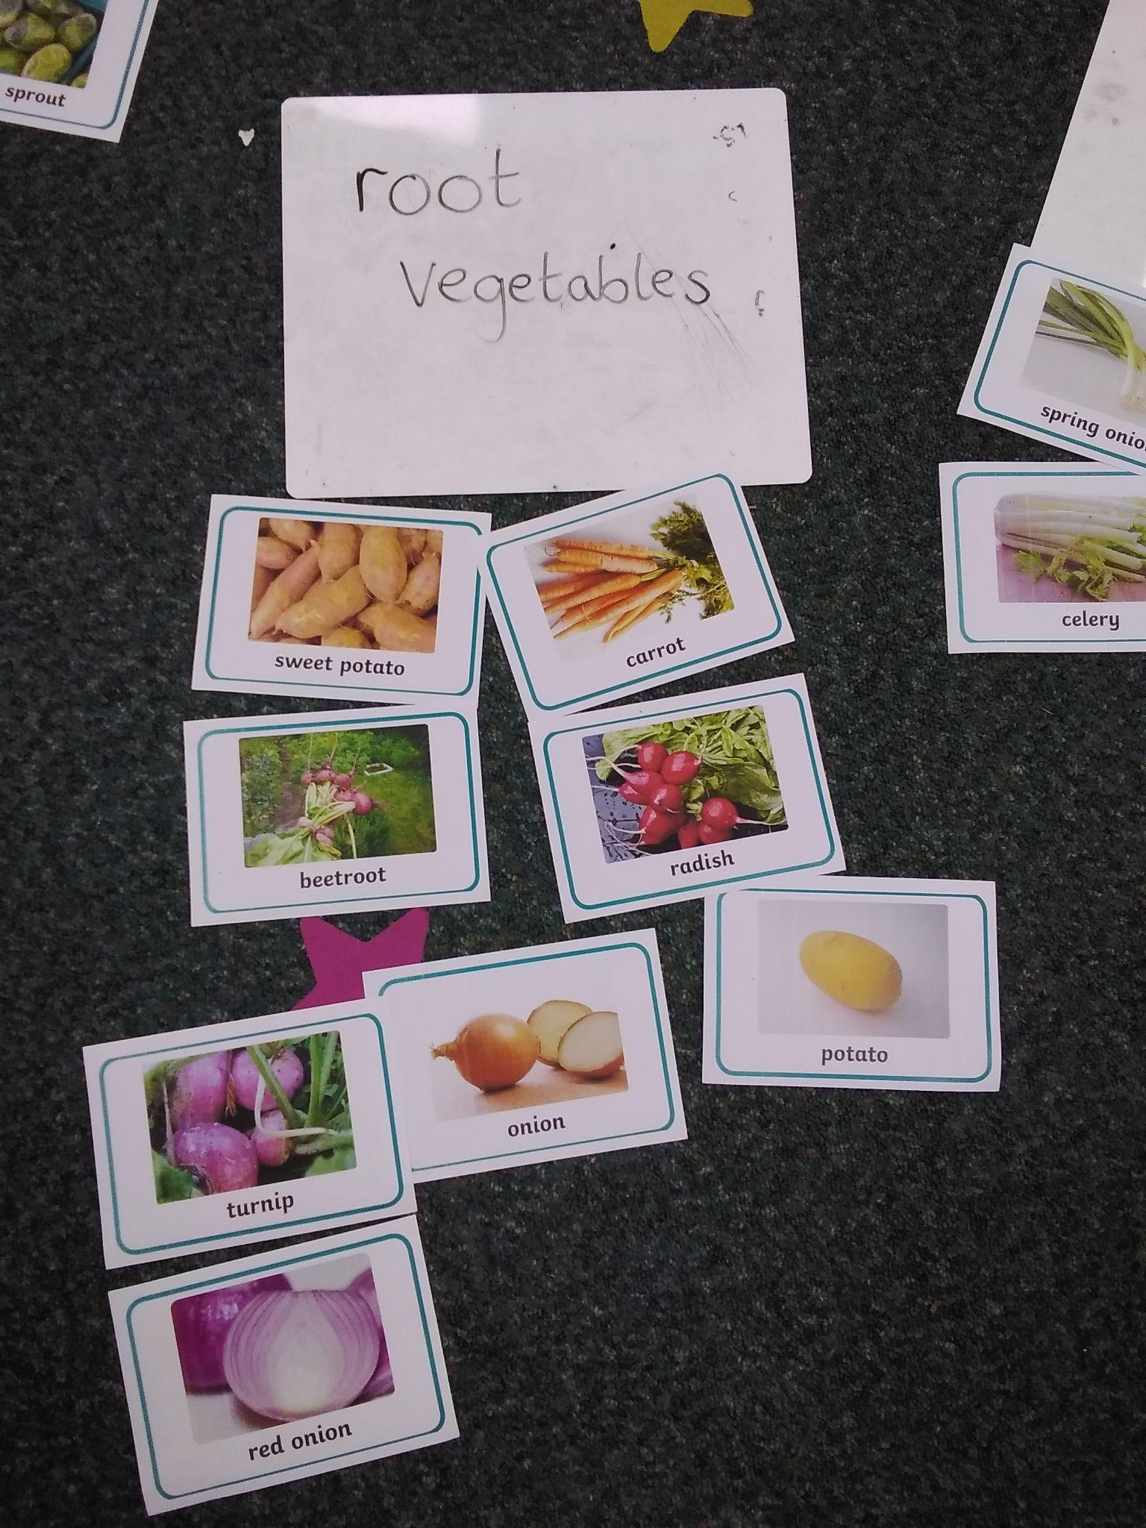
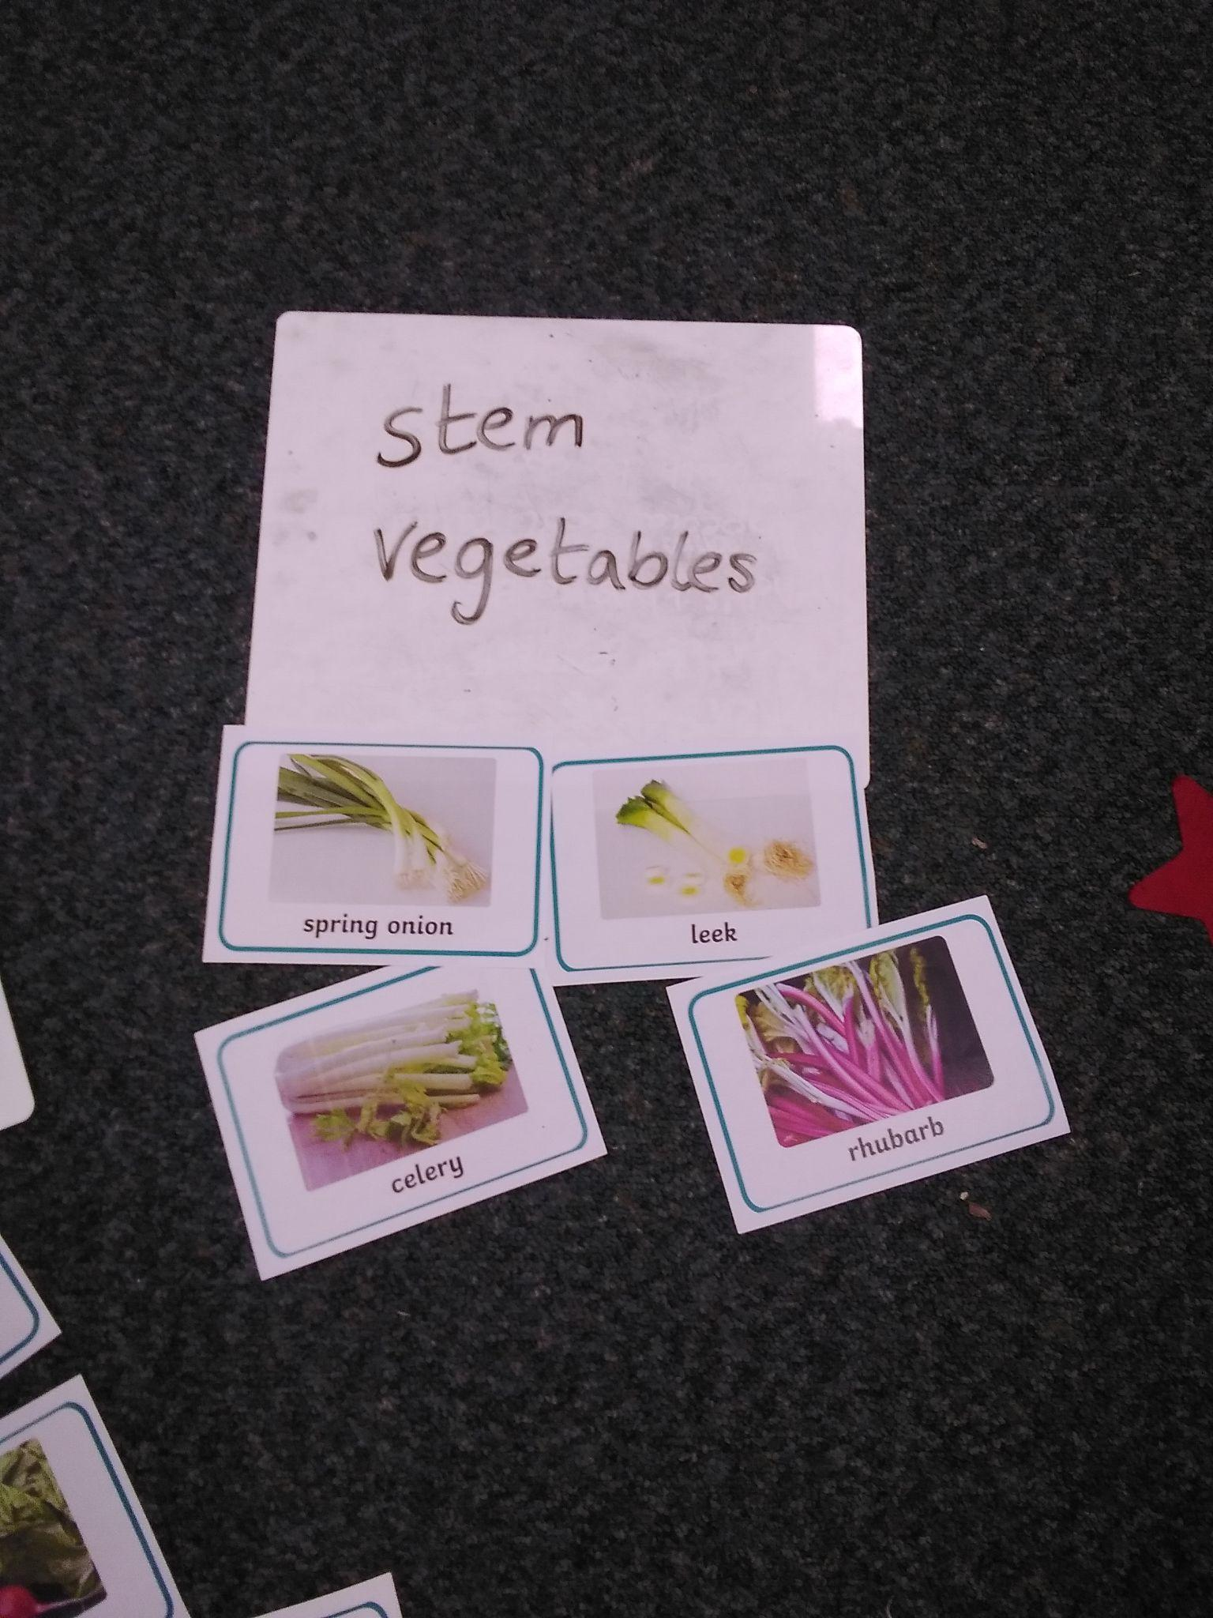

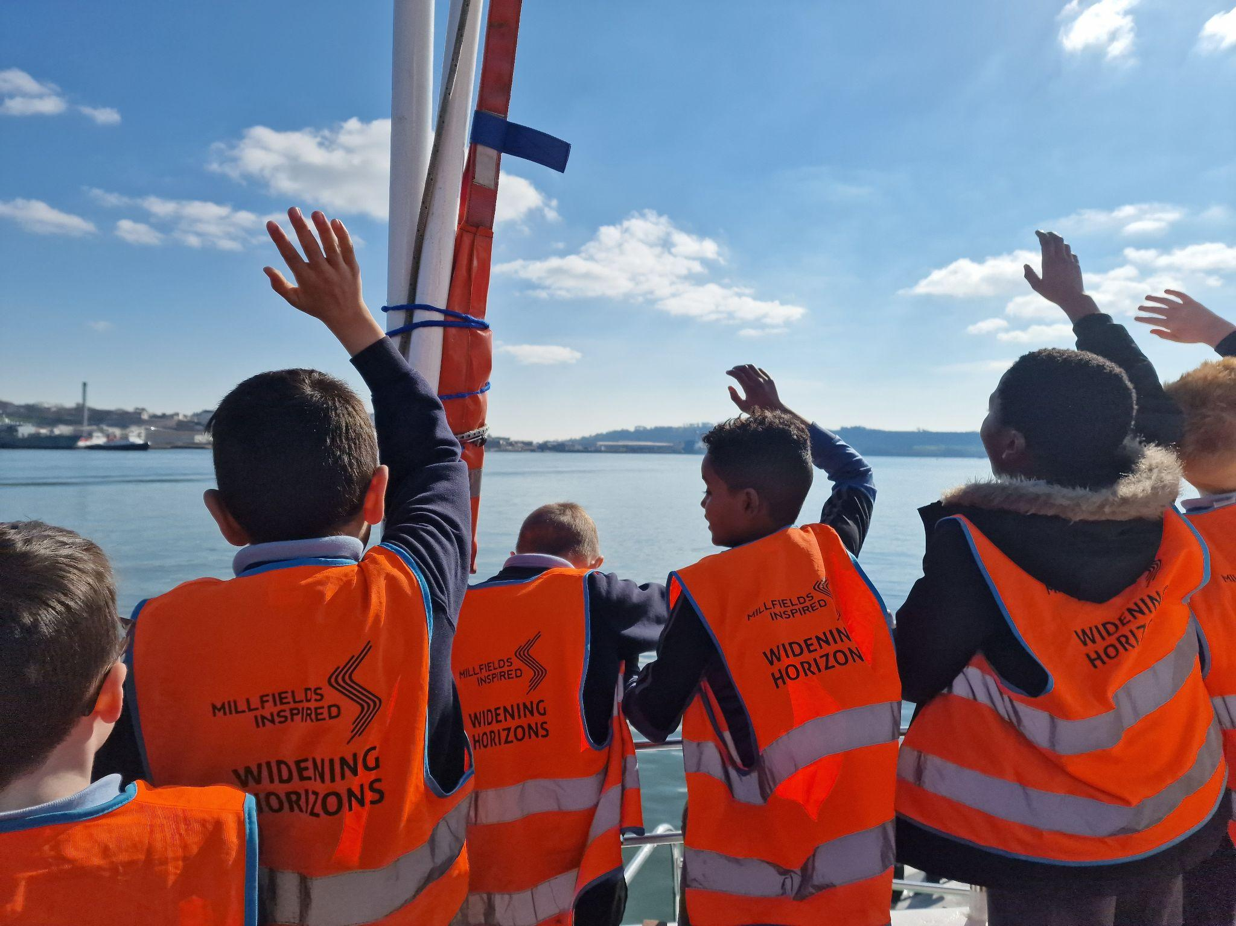

Year 5 Dolphin Class - Harbour visit
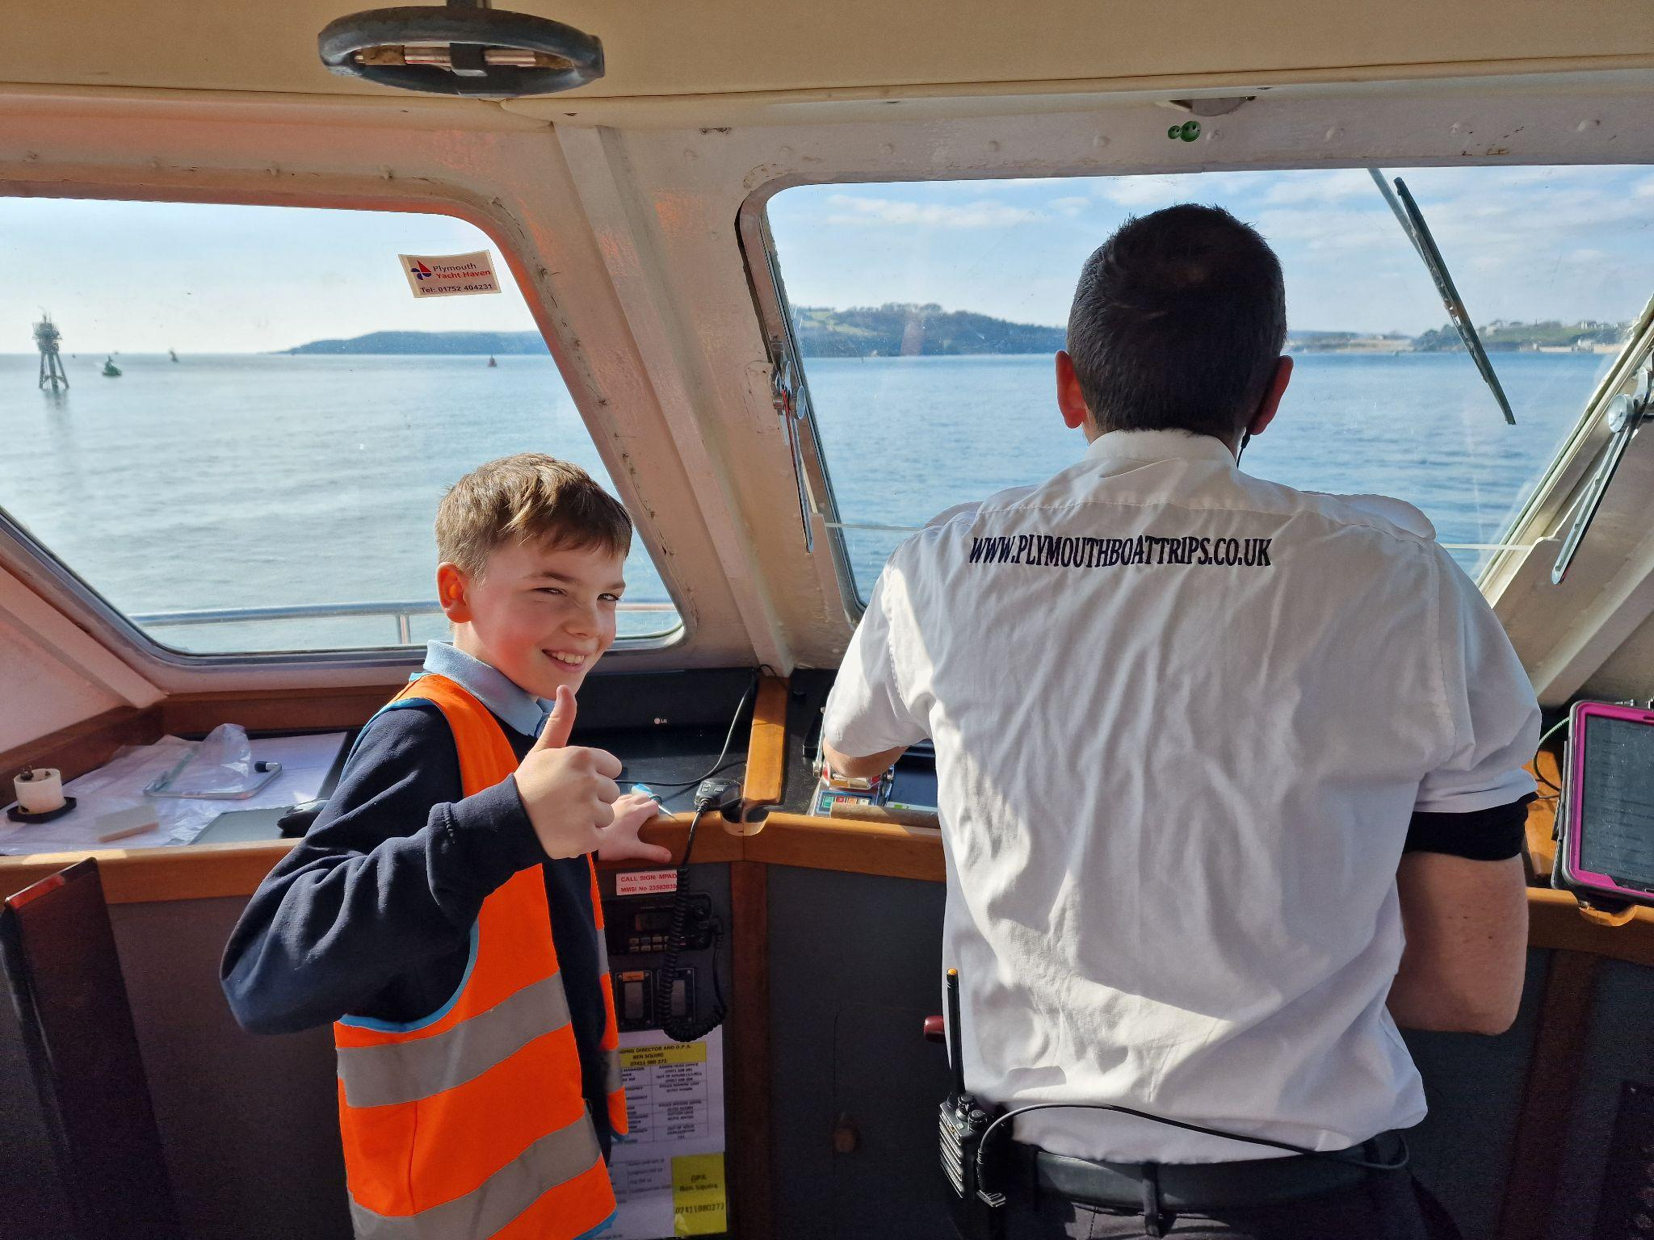
Dolphins had a really interesting and exciting trip to the Harbour Commissioners Office on the Barbican as part of our Widening Horizons programme.. We learnt about the different job opportunities available in making sure that the millions of pounds worth of goods that come into our port, arrive safely. We had a tour of two different types of boats , a tug and a pilot boat. We were super impressed by the pilot boat because it can travel at 22 knots (about 25 mph) and if it capsizes it will right itself without sinking! We finished the day with a boat tour of the harbour and a large cargo ship sounding its horn for us.

Cosy Cottage - Red Nose Day fun!
Over in Cosy Cottage, we had lots of Comic Relief fun with red nose races, pin the red nose on Mr Newell, a red nose treasure hunt and we made red nose cupcakes - YUM!

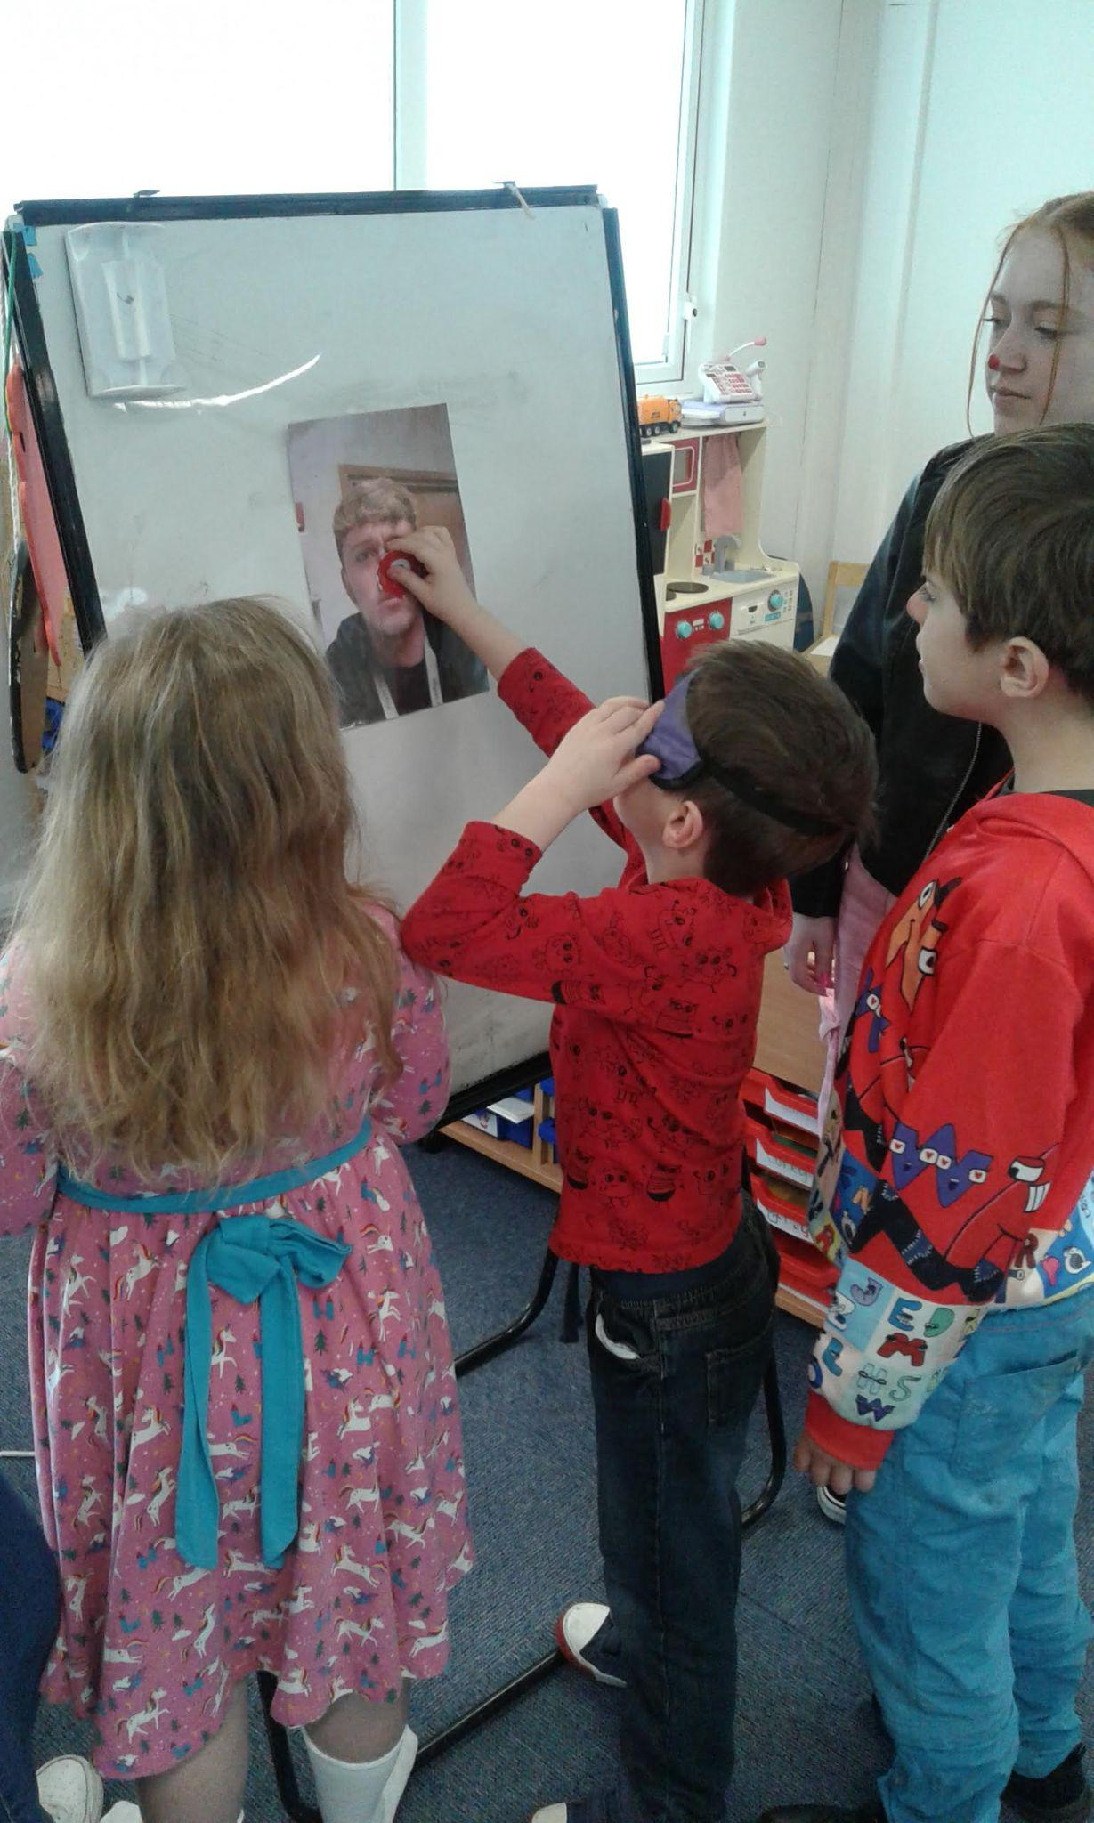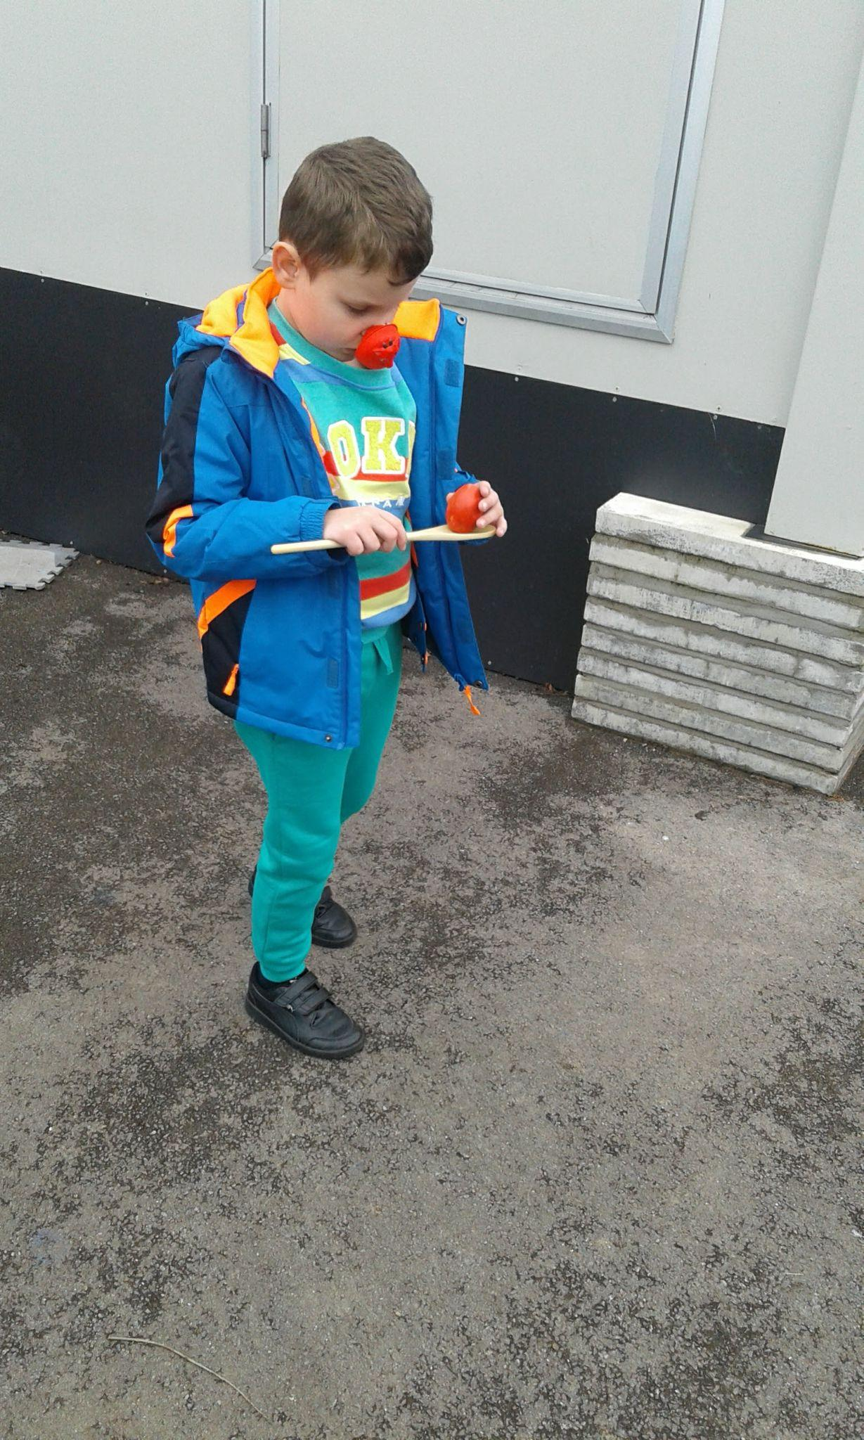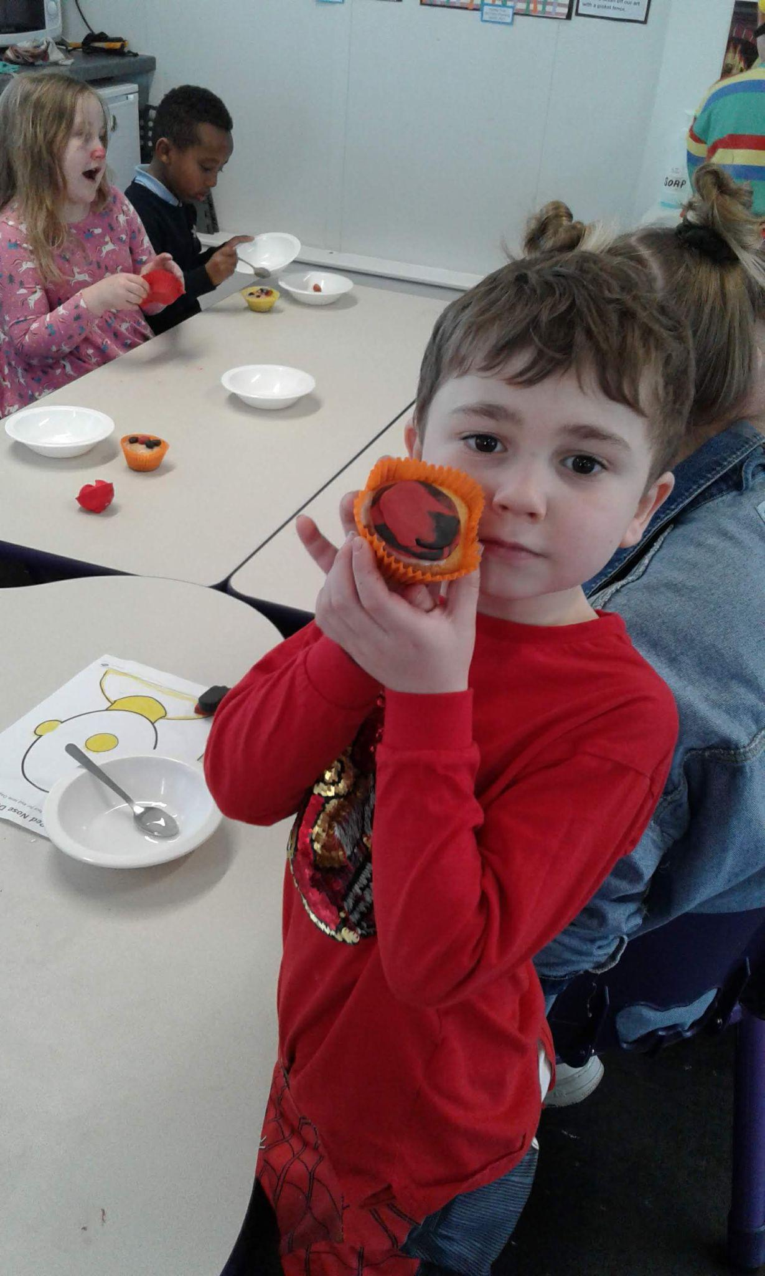


Dates for your Diary

22.03.23 Parents Consultation Meetings - NEXT WEEK
23.03.23 Parents Consultation Meetings - NEXT WEEK
24.03.23 Owls Class Assembly
31.03.23 Orcas Class Assembly
03.04.23 Easter Break
17.04.23 Return to School

Community Information



Fit and Fed Scheme - holiday activities
Fit and Fed clubs provide children with activities (including meals) during the Easter and Summer holiday periods across the city. Clubs are at various venues in Plymouth and offer a variety of activities. If you are entitled to Free School Meals (FSM) this is a FREE scheme. However, Fit and Fed have now changed their policy and some clubs are also offering places for a relatively low price for children who are not entitled to free school meals. Please be aware some clubs are much more expensive than others, ranging from £10.00 to £25.00 a day.
If you would like to know more, check out the venues and the clubs on offer for your age range of children then please click on the link: www.plymouth.gov.uk/fitandfed

Places are often in demand so we would recommend that you try to book early!

Pupils to Celebrate!

We are now presenting a Star Learner recognition in every class weekly AND the children are recognising one of their class team for a Pat on the Back for conduct each week too. Lots to celebrate so well done to these children:

 | PAT ON THE BACK | STAR LEARNER
From 06/03/2023
until 17/03/2023
Year 1 | Leyland S / Alisa A / Flora A / Kalyan G | Jolicia B / Amelia T / Samuel C / Hasan A
Year 2 | Adejare A / Alice K / Zuhir R / Eva M | Jwad Y / Theo W / Annabel A / Zion B
Year 3 | Avin G / Harmony K-J / Oskar C / Katie W | Avin G / Shabat T / Ethan L / Layla L
Year 4 | Mason C / Jethro F-K / Mohammed B / Sonny D | Shaye T / Arthur C / Alfatih O / Joey W
Year 5 | Louis J / Tomasz K / Mia M-W / Lacey W | Emma C / Jamal A / Vinnie M / Arsema M
Year 6 | Abraheem L / Piotr B / Honor F / AJ D | Tiana H / Serena A / Zander R / Caitlin M

Attendance
Attendance for the year to date is 92.2%. This is still lower than we would like so please make sure that children are in school every day unless they are ill. Holidays in term time are not authorised and are likely to lead to a fine for unauthorised absence.
Well done! Dolphins in Year 5 are absolutely smashing the attendance leaderboard. They are still the best attending class of the year to date and they also have the best attendance in the last fortnight. Go Dolphins!

Pilgrim Primary Attendance  (398 pupils) | Attendance School  (target 95%+) | Attendance National  (Primary schools) | Lateness  (pupils arriving after 9.00 am)
Up to w/e  17.03.23 | 92.2% | 93.5% | 1.3%
Best class  (year to date)  95.4% | Year 5 Dolphins   | Best class  (last fortnight)  96.8% | Year 5 Dolphins
 There are 44 pupils in school with 100% attendance to date! 

As you can see, we have had a busy but fun-packed fortnight. Thanks for supporting your children to raise money today. Don’t forget to look out for an email to sign up to next week’s teacher consultation meetings - it would be great to see you all in school for an appointment.

Please have a good weekend and see you on Monday.

Mrs L Meek
Headteacher

